23/24 Usability Engineering ref coursework

Table of Contents

Introduction 4

**Section 1: Identifying the users and problems of the current prototype 4**

1.1 Personas 5

1.2 Research on vulnerable user group 10

1.3 Usability Analysis 11

1.4 Description of problem and current solutions 12

**Section 2: Designing a user-centred solution to solve the problems from Section 1 14**

2.1 Hierarchical Task Analysis 14

2.2 Prototypes 19

2.3 How do these prototypes differ from the original ones 24

2.4 Added feature 24

**Section 3: Design a user study to evaluate your solution from Section 2 25**

3.1 Study Design 25

3.2 Materials 25

3.3 Participants 25

3.4 Procedure 25

3.5 Data Collection 26

3.6 Analysis 26

3.7 Limitations 26

3.8 Reporting 27

**Appendix 27**

Use of AI 28

## **Introduction**

Newly independent users especially users with learning disabilities, are more likely to require lots of support, in different aspects of their lives and cooking

is one of them. And that is simply because, how could we survive without fueling our bodies? Not much of an easy task. For that reason, everyone must

feel included and comfortable, with cooking. The current prototypes have good intent, which is mainly to help young people and people with needs, to cook healthy, and cheap simple meals, However, they face several usability challenges that defy the ease of navigation and overall user experience. This report includes an analysis of the current prototypes, the development of improved prototypes, and a comprehensive user study of the new design.

# **Section 1: Identifying the users and problems of the current prototype**

## **1.1 Personas**

| Name:  Jessica Xhian | Age: 18 | **Characteristics:**  Jessica lives in a small apartment near Reading University. She is from a supportive family but needs to manage cooking on her own for the first time. |
| --- | --- | --- |
| **Short descriptor:** Recently moved out for University, trying to become independent. | |
| Photo: | | **Goals**: To learn how to cook affordable and healthy meals for herself to stay fit and save money |
| **Scenario:**  Jessica is using the app to find easy recipes she can cook after her classes. She wants to learn basic cooking skills to avoid eating out frequently. |
| **Problems:**  Jessica might struggle with understanding complex recipes due to her inexperience in cooking. She may also find it hard to manage her time between studies and cooking. |

# 

# 

| **Name:**  Callum Stones | **Age**: 20 | **Characteristics:**  Lives in a shared apartment with friends. His ADHD makes it difficult to focus on long and complex tasks*.* |
| --- | --- | --- |
| **Short descriptor:** A college student with ADHD trying to manage his diet and health. | |
| Photo: | | **Goals:**  To find simple, quick recipes that he can cook without losing focus or getting overwhelmed*.* |
| **Scenario:**  Callum uses the app to quickly find step-by-step guided recipes that don’t require long periods of concentration. He prefers recipes with video instructions. |
| **Problems:**  Callum might get distracted by advertisements and find it hard to follow through with the cooking process if it’s not engaging enough. |

# 

# 

# 

# 

# 

| **Name**:  Lara Durocher | **Age**: 19 | **Characteristics:**  Lives in a University accommodation in Coventry. She struggles with reading and processing written information quickly. |
| --- | --- | --- |
| Short descriptor: A dyslexic young woman aiming to improve her cooking skills. | |
| **Photo:** | | **Goals:**  To learn to cook healthy meals independently without relying on text-heavy instructions. |
| **Scenario:**  Lara is using the app to access recipes that have more visual and audio instructions rather than written text, making it easier for her to follow along. |
| **Problems:**  Lara may find it difficult to navigate text-heavy parts of the app or misunderstand complex instructions due to her dyslexia. |

# 

# 

# 

# 

| Name:  Mark Trumpfan | Age:  16 | Characteristics:  Mark lives in a small house with his elderly grandparents who are unable to help much with daily tasks. As a result, he istrying to become self-sufficient after the loss of his parents. |
| --- | --- | --- |
| Short descriptor: A teenager living with his grandparents. | |
| Photo: | | Goals:  To learn basic cooking skills to prepare meals for himself and occasionally for his grandparents. |
| Scenario:  Mark uses the app to find simple and nutritious recipes that he can prepare with limited ingredients and cooking knowledge. He needs clear, straightforward instructions. |
| Problems:  Mark may face emotional challenges and lack confidence in his cooking abilities. He might also need more basic guidance than other users. |

# 

# 

# 

# 

# 

# 

# 

# 

# 

# 

# 

# 

# 

# 

# 

# 

# 

# 

# 

# 

# 

# 

| **Name:**  John Chiraq | **Age:**  20 | **Characteristics:**  John lives in a studio apartment. His dyspraxia makes it difficult for him to coordinate his movements, affecting his ability to cook. |
| --- | --- | --- |
| **Short descriptor**: An independent young man with dyspraxia working to improve his life skills. | |
| Photo: | | **Goals:**  To learn to cook simple meals that don’t require precise movements or complex multitasking. |
| Scenario:  John uses the app to find recipes that are specifically designed for people with motor coordination difficulties, featuring step-by-step visual and audio instructions. |
| Problems:  John may struggle with recipes that require a lot of fine motor skills or precise timing, leading to frustration and possible accidents. |

## 

## **1.2 Research on vulnerable user group**

Generally, when discussing vulnerable user groups, we tend to talk about groups of individuals exposed to “risks” [7] of something. Whether it is being at risk emotionally, a vulnerable user is an individual with needs. For that reason, when discussing vulnerable user groups in the digital world that we live in, we often tend to refer to people with needs, designing systems or solutions that would be accessible for all, so everyone can feel included. In our case, we have two groups of users who could be considered vulnerable: users with learning disabilities and our young users.

Users with learning disabilities, such as dyslexia, ADHD, and dyspraxia, face specific challenges that can make navigating digital interfaces difficult. They may struggle with reading text, remembering instructions, or focusing on tasks [2], increasing the risk of frustration and abandonment of the app [3]. Young users, particularly those who are newly independent, are also vulnerable. They may lack experience and confidence in cooking, leading to anxiety and dependence on clear, supportive instructions [3]. They are at risk of developing unhealthy eating habits if they cannot access or use resources that teach them how to cook healthy, simple meals [5].

It is important to bear in mind the needs of these groups when designing the app. Ensuring that the app is intuitive, provides clear feedback, and offers accessible support can mitigate these risks. By prioritising usability and accessibility, we can create a more inclusive digital environment where all users, regardless of their vulnerabilities, can feel empowered and supported.

## **1.3 Usability Analysis**

| **Screen** | **Heuristic Violated** | **Description** |
| --- | --- | --- |
| Screen 1 | 1. Visibility of system status | The "Register" button is confusing, as its placement at the top might make users think it's the company name or a logo. Also, "register" is misspelled, adding to the confusion. |
| Screen | 2. Match between system and real world | The password input box appears before the email input box, which is unconventional and confusing. |
| Screen | 3. User Control and Freedom | No "Password forgotten" feature is provided, making it hard for users to recover their accounts. |
| Screen 1  Screen 1a | 4. Consistency and Standards | 1.The "Email/Name" input box is confusing as it mixes two different concepts.  2. Also, The large logo with "learn to cook" text is unclear whether it's a button or the app's logo. |
| Screen 1a | 5. Error Prevention | If wrong log in details entered, user’s will get redirected to home page, without knowing which would lead to confusion |
| Screen 4 | 6. Recognition rather than recall | Door not being labelled, user is forced to remember it’s function |
| All Screens | 7. Flexibility and Efficiency of use | The house icon, and the “<” button, both having the same feature is a great example of the 7th heuristic being violated. |
| Screen 5a | 8. Aesthetic and Minimalist design | Massive ad box could distract users, especially those with needs like ADHD or Dyspraxia |
| Screen 1b | 9. Help users recognise, diagnose and recover from errors | User isn’t told that if entering invalid data, they will be redirected to Screen 1. |
| Screen 3 | 10. Help and documentation | Ingredients are hyperlinks, but not documented anywhere that they will get redirected to a browser |

**Conducting the Heuristic Analsysis**

In order to comprehensively assess the usability of our cooking app prototype, we carried out a heuristic analysis using Nielsen's ten usability heuristics. This approach entails a thorough analysis of the interface to pinpoint any potential issues that could impede the overall user experience. Allow me to provide you with a comprehensive breakdown of our process:

We used Jakob Nielsen's ten usability heuristics as our evaluation framework to guide our selection of heuristics. These heuristics have gained widespread recognition and encompass a wide range of usability principles, making them well-suited for our analysis.

**Assessment Procedure:**

Creating the Evaluation Team: Our evaluation team was comprised of individuals who possess expertise in usability and stakeholders who have a deep understanding of the app's intended users, including individuals with learning disabilities.

We developed a set of evaluation criteria using Nielsen's heuristics to assist us in our analysis. Every screen of the app was evaluated based on these criteria.

Review Process: The evaluation team thoroughly examined the app's screens, carefully identifying any instances where the heuristics were not followed. The screens were evaluated for factors such as visibility, user control, consistency, error prevention, and other important usability principles.

The consolidation about Findings: The team came together in meetings to discuss and prioritise the issues, considering their severity and effect on the user experience.

## **1.4 Description of problems with current prototypes**

1. Screen 1: Landing Page
   * **Issue**: "REgister" is not spelt properly. This inconsistency can be confusing and looks unprofessional.
   * **Issue**: The "Learn to Cook" text is not very prominent and can be missed. Users with ADHD might miss the purpose of the app due to a lack of emphasis.
   * **Issue**: The "50% off produce from Ubereats" ad is very prominent. This can be distracting for users with ADHD and dyspraxia.
2. Screen 1a: Log in
   * **Issue**: The order of input fields is unconventional (password before email). Users might be confused, especially if they expect standard conventions.
   * **Issue**: There is no indication of password requirements. Users with dyslexia might struggle if their password is not accepted without clear guidance.
3. Screen 1b: Registration
   * **Issue**: Gender and ethnicity fields might feel intrusive and unnecessary. Users might be reluctant to fill these out, especially if they feel it’s irrelevant to the app's purpose.
   * **Issue**: Same password and email order issue as in the login screen. This inconsistency can be confusing.
4. Screen 2: Home Screen
   * **Issue**: The ad placement is very prominent and distracting. Users with ADHD might be unable to focus on the main content.
   * **Issue**: The menu items are not differentiated. Users with dyslexia (Lara Durocher) might find it difficult to quickly identify and select options.
5. Screen 3: Ingredients
   * **Issue**: The ad placement needs to be more moderate and take up significant space.Users might miss the actual content due to distractions.
   * **Issue**: Clicking on ingredients opens a new tab with a Google search. This disrupts the user flow and can be confusing for inexperienced users.
6. Screen 4: Menus
   * **Issue**: The “Buy VPN” ad is irrelevant and confusing. Users might be confused about the link between a cooking app and a VPN ad.
7. Screen 6: No Stove No Problem
   * **Issue**: The description indicates no hyperlinks, but there is a blue underlined font. This inconsistency can be confusing and misleading.
   * **Issue**: Certain references, not being documented such as on Screen 5a, fourth instruction, saying use George Forman, but some users might not know what or who George Forman is

The prototypes developed in Section 2 aim to address the following heuristic issues: visibility of system status, match between system and real world, user control and freedom, consistency and standards, error prevention, recognition rather than recall, flexibility and efficiency of use, aesthetic and minimalist design, help users recognise, diagnose, and recover from errors, and provide help and documentation.

# **Section 2: Designing a user-centred solution to solve the problems from** [**Section 1**](https://docs.google.com/document/d/1miD_ndG-i3XjPboBWj2zWIeJUGH8qLrxgZYqGgZ0tTI/edit#heading=h.6ofxjcdxr053)

## **2.1 Hierarchical Task Analysis**

**HTA 1: Task 1: Find a Recipe for a Cheese and Onion Toastie**

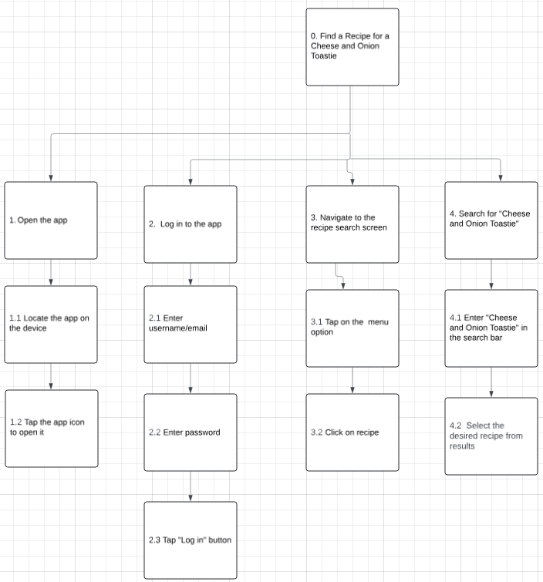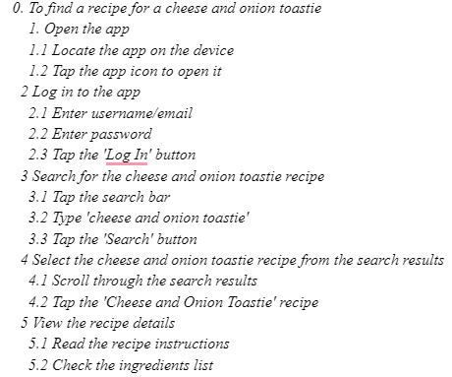

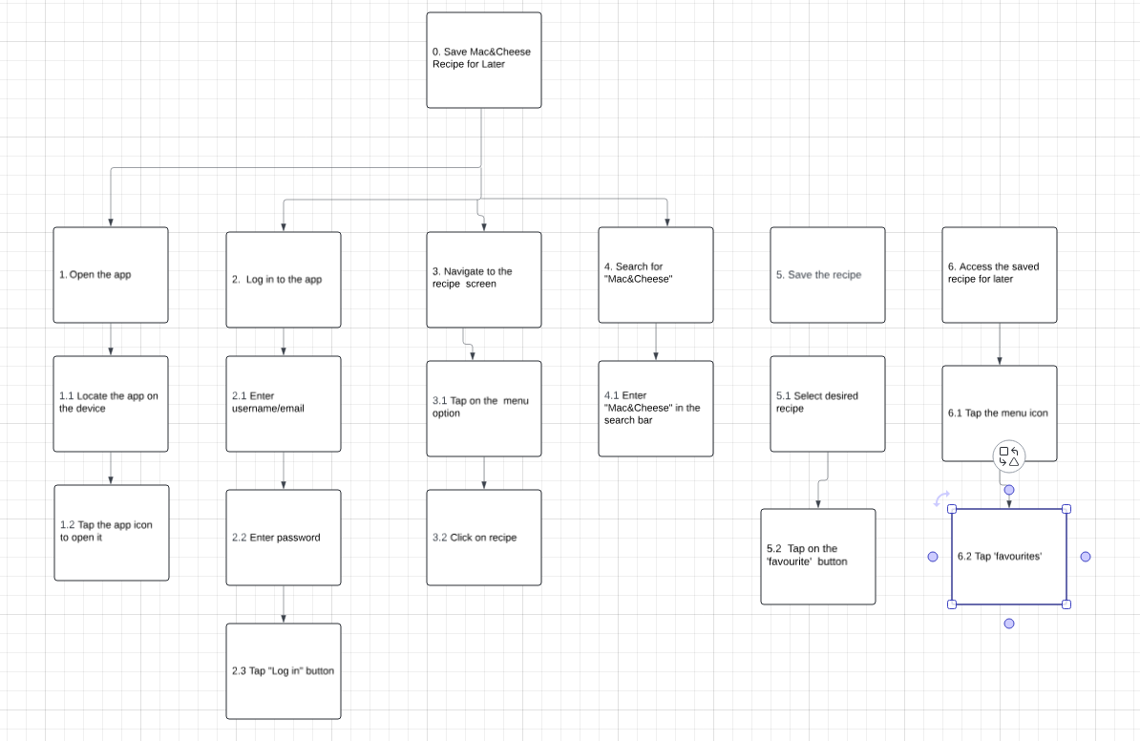

**HTA 2: Save the Mac&Cheese Recipe for Later**

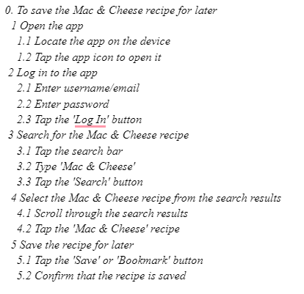

**HTA 3: To Cook fish and Chips**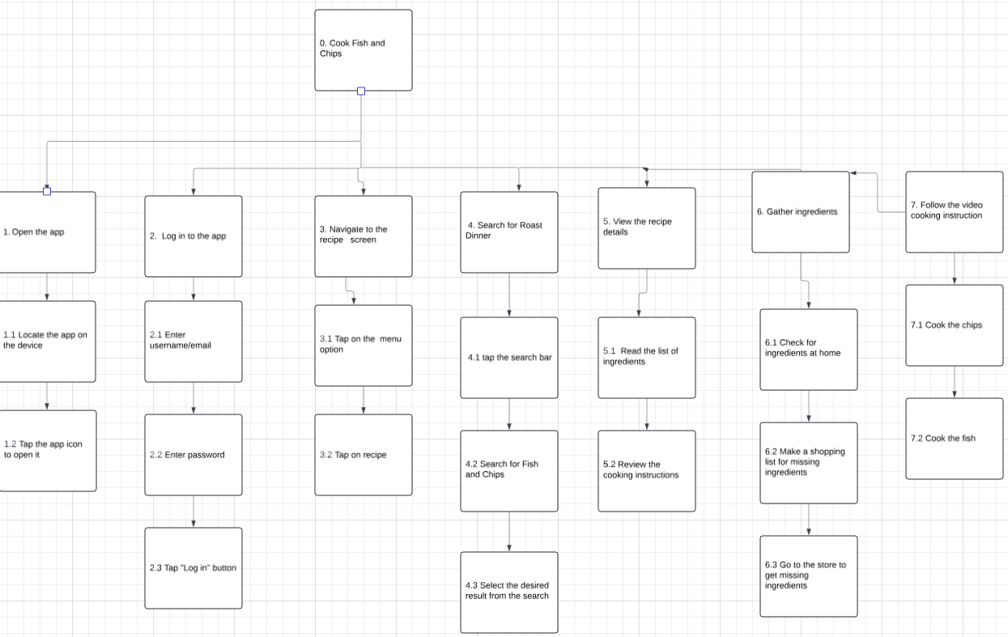

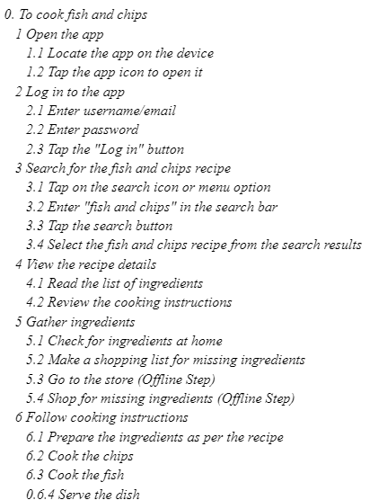

### 

**HTA 4: See what ingredients are required for a Roast Dinner** 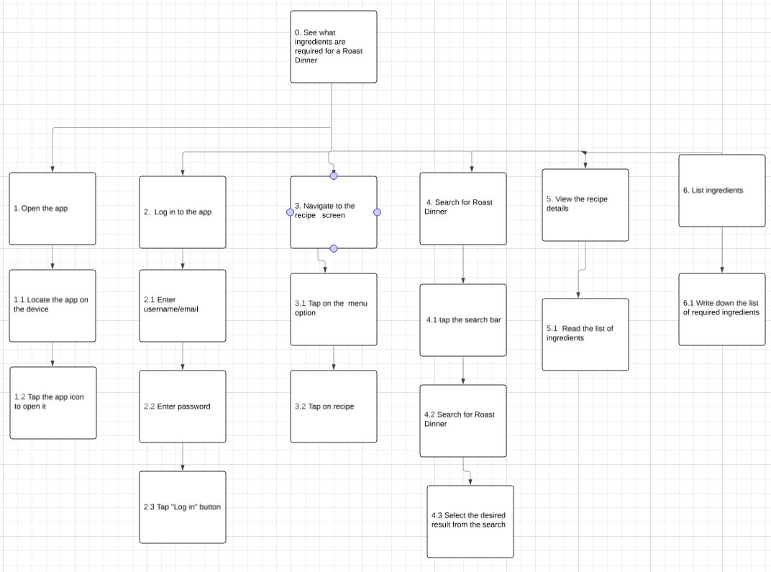

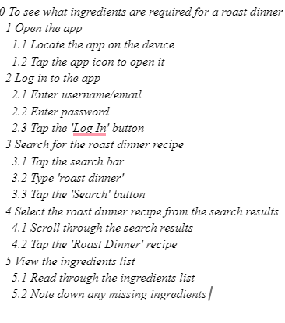

**HTA 5: Use the App to Shop for Ingredients**

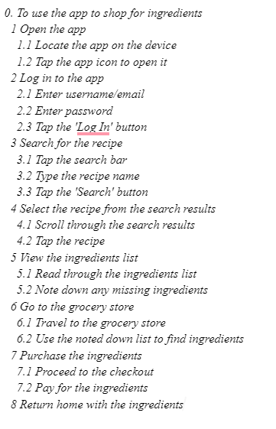

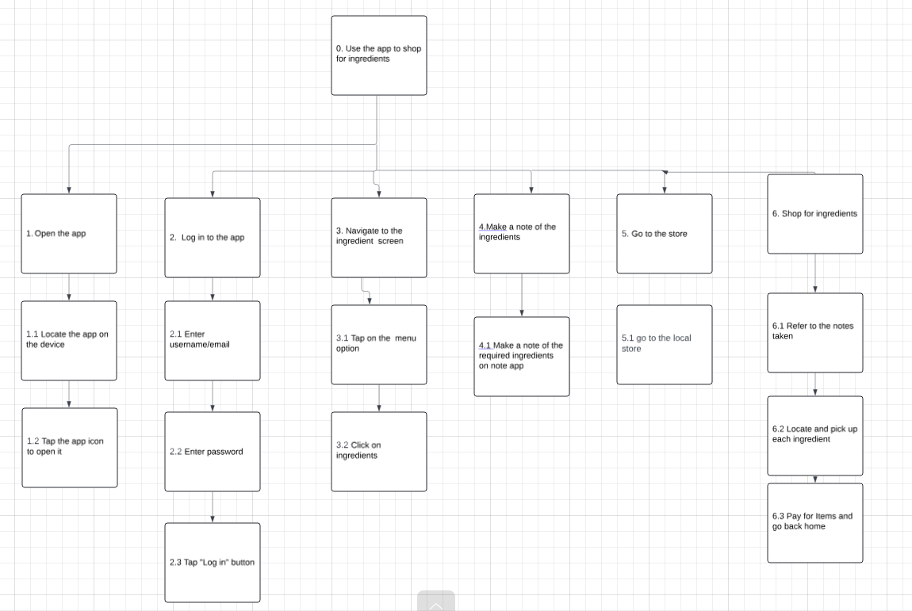

## **2.2 Prototypes**

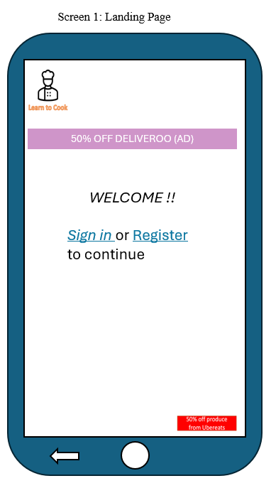 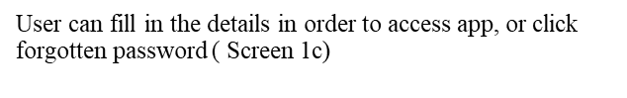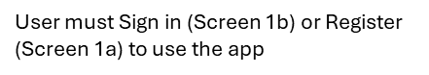

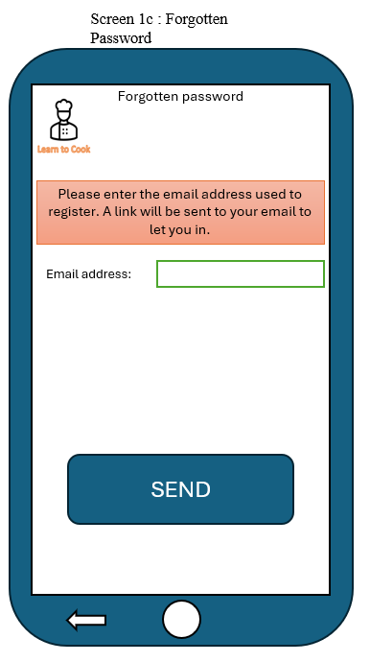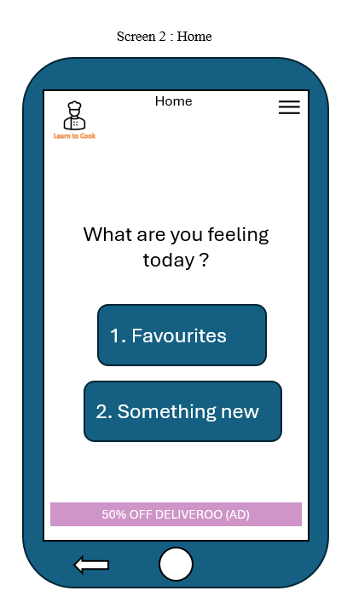

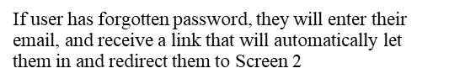

## 

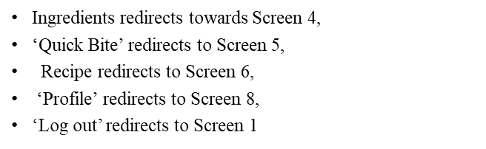

## 

## 

## 

On All screens:

 displays a menu, with different buttons

 When clicked, If user logged in, it redirects to Screen 2, if not it redirects them to Screen 1.

## **2.3 How do these prototypes differ from the original ones**

These prototypes differ from the original ones in many ways, ensuring that all user groups feel included by adding features designed to improve accessibility and usability. These enhancements address the specific needs of vulnerable users, making the app more intuitive and engaging.

## **2.4 Added Features**

* **An Actual Menu**: Provides a structured and easy-to-navigate layout, which helps users quickly find what they need, reducing cognitive load [6].
* **Pictures**: Visual aids support comprehension, especially for users with dyslexia or limited reading skills [7].
* **Audio**: Audio instructions help users with reading difficulties by providing an alternative way to access information [8].
* **Videos**: Step-by-step video tutorials offer visual and auditory learning, beneficial for users with various learning styles and disabilities [9].
* **Icons**: Clear, universally recognised icons enhance navigation and usability, helping users with cognitive impairments [10].
* **Colour Groups**: The use of colour coding helps in differentiating sections and guiding users, which is particularly useful for those with attention difficulties [11].
* **Favourite Page**: Allows users to save and easily access preferred recipes, providing convenience [12] and efficiency.
* **Ads**: Carefully placed, non-intrusive ads ensure funding without disrupting user experience, maintaining a balance between usability and monetization [13].

# 

# **Section 3: Design a user study to evaluate your solution from** [**Section 2**](https://docs.google.com/document/d/1miD_ndG-i3XjPboBWj2zWIeJUGH8qLrxgZYqGgZ0tTI/edit#heading=h.bf2td64k17ea)

## **3.1 Study Design**

**Type**: Qualitative study.

**Aim**: Explore user experiences and identify usability issues to improve the app's design and functionality.

## **3.2 Materials**

* **Interview Topic Guide**: Open-ended questions to explore user experiences.
  + Examples:
    - "Can you describe your experience finding a recipe?"
    - "What challenges did you face while saving a recipe?"
* **Prototypes**: Interactive versions of the app screens needed for tasks.
* **Venue/Equipment**: Quiet room with a computer/tablet, screen recording software, and interview audio recording.

## **3.3 Participants**

* **Number**: 10-15 participants.
* **Characteristics**: Newly independent teenagers and young people aged 16-24, including those with dyslexia, ADHD, and dyspraxia.
* **Recruitment**: Social media, local community centres, educational institutions.
* **Comparison to Personas**: Participants will be selected to match the user personas described in Section 1 (e.g., dyslexia, ADHD, dyspraxia).

## **3.4 Procedure**

1. **Introduction**:
   * Welcome participants and explain the study's purpose.
   * Obtain informed consent.
   * Provide an overview of the app.
2. **Task Execution**:
   * **Tasks**:
     + Find a recipe for a cheese and onion toastie.
     + Save the Mac & Cheese recipe.
     + View ingredients for a roast dinner.
     + Use the app to shop for ingredients.
     + Cook Fish and Chips.
   * Ask participants to verbalise their thoughts while performing tasks (think-aloud protocol).
   * Observe and record actions and any difficulties faced.
3. **Post-Task Interviews**:
   * After completing all tasks, conduct a semi-structured interview to gather detailed feedback on the overall user experience.
   * Example questions:
     + "What did you like most about the app?"
     + "What did you find most challenging or frustrating?"
     + "Do you have any suggestions for improving the app?"
     + "How did the app help you in achieving your cooking goals?"

## **3.5 Data Collection**

* **Observations**: Document usability issues and user interactions during task execution.
* **Interviews**: Gather qualitative data on user experiences and suggestions.

## **3.6 Analysis**

* **Qualitative Analysis**:
  + Transcribe and code interview responses.
  + Use thematic analysis to identify recurring themes and insights.
  + Create a table of changes based on identified issues and user feedback.

## **3.7 Limitations**

* **Sample Size**: A small sample size may limit generalisability.
* **Bias**: Self-selection bias as participants are volunteers.
* **Controlled Environment**: May not fully replicate real-world use.

## **3.8 Reporting**

* **Summary of Findings**: Highlight key usability issues and user feedback.
* **Recommendations**: Provide specific suggestions for app improvements.
* **Visualisations**: Include quotes or excerpts from interviews to support qualitative findings.

# **Appendix**

**Use of AI**

| Use of AI This report utilised AI in the following areas (please check):   * Improving phrasing and writing style * Generating ideas * Revising methods/techniques * Knowledge checking * Structuring the report * Other (please specify)_______________________________   I used the following prompts (please list):   * What is another word for everyone? * What is a better way of saying _____ ? * What can i use to make prototypes ? * How to Approach HTA in usability ? * What kind of tasks would users want to do within a cooking app ? * Could you generate 5 names for me * What is the APA7 Format again? * How would you design a User Study * What are the differences between Qualitative and Quatitive User studies   The AI tool(s) used: _______________________ |
| --- |

**References:**

This-person-does-not-exist.com

**[1]** *vulnerable. (2024).* [*https://dictionary.cambridge.org/dictionary/english/vulnerable*](https://dictionary.cambridge.org/dictionary/english/vulnerable)

[2]Snowling, M. J., & Hulme, C. (2012). The nature and classification of reading disorders—A commentary on proposals for DSM-5. Journal of Child Psychology and Psychiatry, 53(5), 593-607.

[3] Anderson, J., & Rainie, L. (2012). Millennials will benefit and suffer due to their hyperconnected lives. Pew Research Center.

[4]Barkley, R. A. (2014). Attention-deficit hyperactivity disorder: A handbook for diagnosis and treatment. Guilford Publications.

[5]Story, M., Neumark-Sztainer, D., & French, S. (2002). Individual and environmental influences on adolescent eating behaviors. Journal of the American Dietetic Association, 102(3), S40-S51.

[6] Norman, D. A. (2013). The design of everyday things: Revised and expanded edition. Basic Books.

[7] Evans, B. J. W. (2004). Dyslexia and vision. Wiley.

[8] Schneider, E., & Crombie, M. (2003). Dyslexia and foreign language learning. David Fulton Publishers.

[9] Mayer, R. E. (2009). Multimedia learning. Cambridge University Press.

[10] Grier, D. A. (2012). Iconic communication. IEEE Annals of the History of Computing, 34(1), 96-97.

[11] Ware, C. (2012). Information visualization: Perception for design. Elsevier.

[12] Nielsen, J. (2005). Ten usability heuristics. Nielsen Norman Group.

[13] Benway, J. P., & Lane, D. M. (1998). Banner blindness: Web searchers often miss "obvious" links. ITG Newsletter.